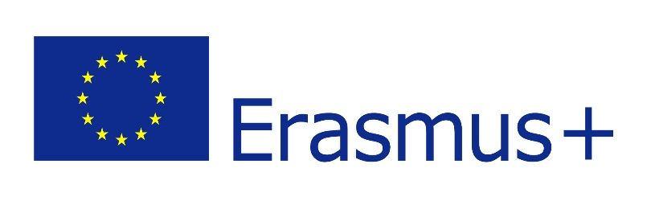
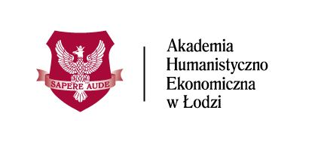

This application should be completed ON COMPUTER in order to be read easily.

ERASMUS+ STUDENT APPLICATION FORM

Akademia Humanistyczno-Ekonomiczna w Łodzi
(PL LODZ07)

I apply for:

Academic year 20…../20…..

winter | spring | full year

Student’s photo

Name of the sending Institution:

……………………………………………..
Name of the course at sending Institution:
………………………………….
Proposed course of study at AHE:

……………………………………….

STUDENT’S PERSONAL DATA (to be completed by the student applying)
Family Name (s): | First Name (s):
Date of Birth: | Place of Birth:
Nationality: | Sex:
E-mail: | Telephone:

SENDING INSTITUTION
Name: | Erasmus ID Code:
Erasmus+ Coordinator/ contact person: | e-mail address and telephone number:

STUDY CYCLE

 | BACHELOR | Year of studies: I/II/III
 | MASTER | Year of studies: I/II

Student with special needs?
Please indicate:
……………………………………..

Please, enclose to this Application Form signed and scanned documents:
- Learning Agreement or OLA (Online Learning Agreement)
- Language certificate or other confirmation of your English language command level (required level is at least B1) – OLS test accepted

Deadlines:
- 30th of June – for the Winter semester
- 17th of December – for the Spring semester

We inform that the Administrator (an entity determining the purposes and means of processing personal data) of your personal data is University of Humanities and Economics in Lodz, Sterlinga st. 26, 90-212 Lodz, study@ahe.lodz.pl. The contact details of the Information Security Administrator (Personal Data Inspector) are the same as the Administrator's contact details indicated in the previous sentence.

Personal data will be processed for the purposes of admission for studies and all the processes related to studies, events organized by the Administrator and marketing within the scope specified in the regulation of studies and in accordance with the content of the consents granted to the Administrator. The legal basis for processing is activities related to the performance of the contract concluded in the mode of acceptance of the regulations and, if applicable, the consent of the data subject. The data will be processed for the purposes of the contract and 10 years after its implementation (limitation of claims), while the data processed on the basis of the consent of the data subject will be processed until the end of the purpose for which they were collected or opposition for processing personal data of the data subject, whichever comes first. Everyone has the right to request from the Administrator access to personal data, rectification, deletion, processing restrictions, as well as the right to transfer data and object to the processing. Everyone has the right to withdraw consent to the processing of personal data, which he gave to the Administrator. Withdrawal of consent does not affect the lawfulness of the processing that was carried out prior to its withdrawal. Everyone has the right to lodge a complaint to the Supervisory Body [after 25 May 2018 to the President of the Office for Personal Data Protection]. The rights of the data subject, including the withdrawal of the granted consent, may be made by submitting a statement using the contact details of the Administrator or the Personal Data Inspector indicated in the introduction.

[x] I agree to the processing of my personal data and all information provided by me for the purposes of registration, recruitment procedure, and then documenting the course of study, in accordance with applicable laws, as well as for future recruitments run by the University of Humanities and Economics in Lodz.

[x] I agree to receive commercial information (in particular educational offer) via e-mail, landline or SMS (Short Message Service) in accordance with with the Act of 18 July 2002 on the provision of electronic services (Official Journal of Laws – Dz.U.2013.1422 jt) and the Act of 16 July 2004 telecommunications law (Dz.U.2016.1489) concerning the University of Humanities and Economics in Łódź and the Institute of Creative Activity (Instytutu Postępowania Twórczego sp. z o.o. w Łodzi ul. Rewolucji 1905 r. nr 52, 90-213 Łódź).

[x] I agree to the processing of my personal data for marketing and promotional purposes by the University of Humanities and Economics in Lodz and the Institute of Creative Activity in Lodz.

[x] I express for the University of Humanities and Economics in Lodz the permission for free use by AHE in Lodz or other persons acting on its behalf, my image and for the recording and reproduction of this image with all currently available techniques and methods, dissemination and publication in marketing materials serving advertising or promotion of AHE in Lodz and all kinds of scientific, educational and didactic activities conducted by it, in Poland and abroad, for a period of 5 years from the submission of this statement (including by posting in a digital form on the Internet, as well as in the form of photos, videos, posters, advertising brochures, leaflets, calendars, banners, multimedia presentations, announcements, advertisements, etc., emitted by means of various media, in particular paper printouts and Internet and television networks) - the use of a fixed image in the above-mentioned purposes may take place without providing to me the final version of materials with my image by AHE in Lodz.

SIGNATURES
I hereby confirm that the applicant is nominated for the Erasmus+ programme bilaterally  agreed on by our institutions respectively  Institutional Coordinator’s Signature at SENDING Institution:  ………………………………………………  Date:………………………………… | I certify that all the information provided in the application is correct and complete. I hereby consent to my personal information being collected by AHE.  Student’s signature:  ………………………………………  Date………………………………….

The application form and all other documents should be signed electronically or signed and scanned via e-mail to the address:

erasmus@ahe.lodz.pl

